Name-kaveri Avinash Jarhad
Shubhangi Balaji khavle
Assignment -7

• Q-1
• Create a Student class with the following attributes: name, age, and student_id.
• The constructor should initialize these attributes.
• Add a method display_info() that prints the student's details in a user-friendly format.
• Add a method is_eligible_to_vote() that returns True if the student's age is 18 or older, and False otherwise.
• Create a student object and test all the methods
class Student:
def __init__(self, name, age, student_id):
self.name = name
self.age = age
self.student_id = student_id

def display_info(self):

print(f" Student Information ")
print(f"ID: {self.student_id}")
print(f"Name: {self.name}")
print(f"Age: {self.age}")

# def is_eligible_to_vote(self):
# return self.age >= 18
def is_eligible_to_vote(self):
if self.age >= 18:
return True
else:
return False

student1 = Student(name="kaveri", age=22, student_id="1225")
student1.display_info()

eligible = student1.is_eligible_to_vote()
print(f"Eligible to vote {eligible}")

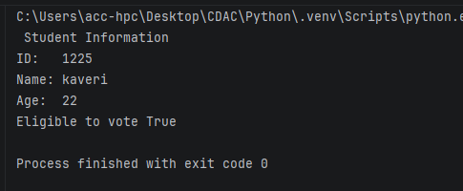
Q-2
• Create a base class Vehicle with attributes: make, model, and year. The constructor should initialize these.
• Add a method display_info() that prints the basic vehicle information.
• Create a child class Car that inherits from Vehicle.
• The Car class should have an additional attribute num_doors. The constructor should take make, model, year, and num_doors.
• Override the display_info() method in the Car class to also include the number of doors.
• Create instances of both Vehicle and Car to demonstrate inheritance and method overriding.
class Vehicle:
def __init__(self, make, model, year):
self.make = make
self.model = model
self.year = year

def display_info(self):
print(f"Vehicle Info: {self.year} {self.make} {self.model}")

class Car(Vehicle):
def __init__(self, make, model, year, num_doors):
super().__init__(make, model, year)
self.num_doors = num_doors

def display_info(self):
print(f"Car Info: {self.year} {self.make} {self.model} | Doors: {self.num_doors}")

generic_vehicle = Vehicle("Yamaha", "MT-07", 2022)
print("Vehicle Instance")
generic_vehicle.display_info()

print()

my_car = Car("Toyota", "Camry", 2024, 4)
print("Car Instance")
my_car.display_info()

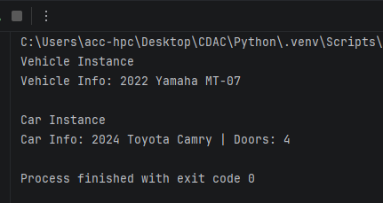
Q.3
• Employee Management System:
• Create a base class Employee with attributes name, employee_id, and salary.
• Create a derived class Manager that inherits from Employee and has an additional attribute for a list of employees they manage.
• Add methods to both classes, such as a method in Manager to add an employee to their managed list.
class Employee:
def __init__(self, name, employee_id, salary):
self.name = name
self.employee_id = employee_id
self.salary = salary

def display_info(self):
print(f"ID: {self.employee_id} | Name: {self.name} | Salary: {self.salary:,}")

class Manager(Employee):
def __init__(self, name, employee_id, salary):
super().__init__(name, employee_id, salary)
self.team = []

def add_employee(self, employee):
if isinstance(employee, Employee):
self.team.append(employee)
print(f"Added {employee.name} (ID: {employee.employee_id}) to {self.name}'s team.")
else:
print("Only instances of Employee can be added.")

def remove_employee(self, employee_id):
for emp in self.team:
if emp.employee_id == employee_id:
self.team.remove(emp)
print(f"Removed {emp.name} from {self.name}'s team.")
return
print(f"Employee ID {employee_id} not found in team.")

def display_info(self):
super().display_info()
print(f"Managed Team ({len(self.team)} member/s):")
if self.team:
for member in self.team:
print(f" - {member.name} (ID: {member.employee_id})")
else:
print(" - No team members assigned yet.")

emp1 = Employee("Kaveri Jarhad", "E101", 65000)
emp2 = Employee("Shubhang Khavle", "E102", 58000)

mgr = Manager("Tanvi Pawar", "M001", 95000)

print("Initial Manager Info")
mgr.display_info()

print("\nAdding Employees to Manager's Team ")
mgr.add_employee(emp1)
mgr.add_employee(emp2)

print("\nUpdated Manager Info")
mgr.display_info()

print("\n Removing an Employee")
mgr.remove_employee("E101")

print("\nFinal Manager Info ")
mgr.display_info()

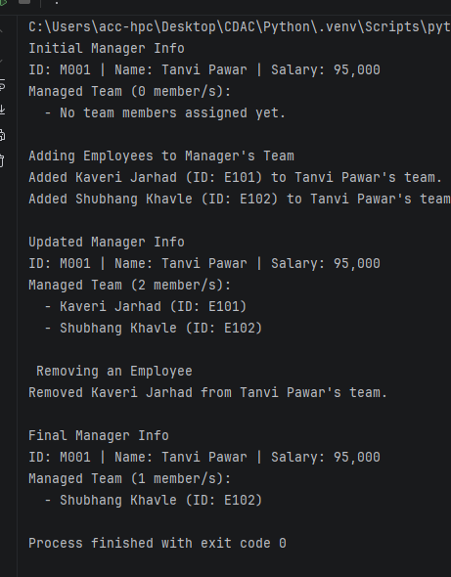
Q.4
Library Management System:
• Create a Book class with attributes like title, author, and is_available.
• Create a Library class that has a list of Book objects.
• Add methods to the Library class to:
o add_book(book): Adds a new book to the library's collection.
o borrow_book(title): Finds a book by title and changes its availability status.
o return_book(title): Changes a book's availability status back to available.
o display_available_books(): Prints the titles and authors of all available books.
class Book:
def __init__(self, title, author):
self.title = title
self.author = author
self.is_available = True

def __str__(self):
status = "Available" if self.is_available else "Borrowed"
return f"'{self.title}' by {self.author} [{status}]"

class Library:
def __init__(self):
self.books = []

def add_book(self, book):
if isinstance(book, Book):
self.books.append(book)
print(f"Added to library: '{book.title}' by {book.author}")
else:
print("Invalid item: Only instances of Book can be added.")

def borrow_book(self, title):
for book in self.books:
if book.title.lower() == title.lower():
if book.is_available:
book.is_available = False
print(f"Successfully borrowed: '{book.title}'")
else:
print(f"Sorry, '{book.title}' is currently checked out.")
return
print(f"Book titled '{title}' was not found in the library.")

def return_book(self, title):
for book in self.books:
if book.title.lower() == title.lower():
if not book.is_available:
book.is_available = True
print(f"Successfully returned: '{book.title}'")
else:
print(f"'{book.title}' was not borrowed.")
return
print(f"Book titled '{title}' was not found in the library.")

def display_available_books(self):
available_books = [book for book in self.books if book.is_available]

print("\nAvailable Books")
if available_books:
for book in available_books:
print(f"• '{book.title}' by {book.author}")
else:
print("No books are currently available.")

city_library = Library()

b1 = Book("1984", "George Orwell")
b2 = Book("To Kill a Mockingbird", "Harper Lee")
b3 = Book("The Great Gatsby", "F. Scott Fitzgerald")

city_library.add_book(b1)
city_library.add_book(b2)
city_library.add_book(b3)

city_library.display_available_books()

city_library.borrow_book("1984")
city_library.borrow_book("1984")

city_library.display_available_books()

city_library.return_book("1984")

city_library.display_available_books()

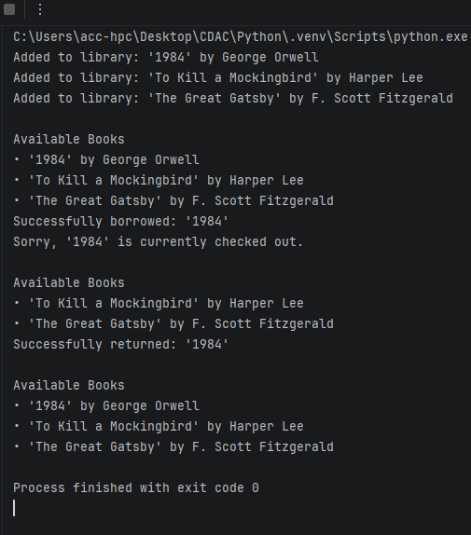

Q.5 Write a Python function is_valid_phone(text) that takes a string and returns True if it is a valid 10-digit phone number, and False otherwise. A valid phone number should consist of exactly 10 digits.
def is_valid_phone(text):
return len(text) == 10 and text.isdigit()

print(is_valid_phone("9876543210"))
print(is_valid_phone("987654321"))
print(is_valid_phone("98765432100"))
print(is_valid_phone("98765abcde"))

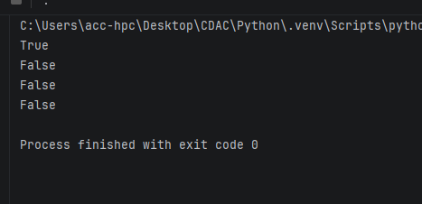
Q.6 Write a Python program to find all words in a string that start with the letter 'p' (case-insensitive) and are at least 3 characters long.
import re

def find_p_words(text):
pattern = r'\b[pP]\w{2,}\b'
return re.findall(pattern, text)

sample_text = "I picked a pair of purple pencils, but pop was too short."
result = find_p_words(sample_text)
print(result)

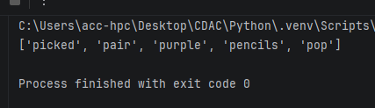
Q.7 Write a Python function find_dates(text) to find the first occurrence of a date in the format MM-DD-YYYY and prints the full match.
import re

def find_dates(text):
pattern = r'\b(0[1-9]|1[0-2])-(0[1-9]|[12][0-9]|3[01])-\d{4}\b'
match = re.search(pattern, text)
if match:
print(match.group())

sample_text = "The Lecture is scheduled for 09-15-2026, and the backup date is 10-20-2026."
find_dates(sample_text)

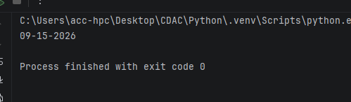
Q.8 Write a Python function is_strong_password(password) that uses regex to check if a password meets the following criteria:
• At least 8 characters long.
• Contains at least one uppercase letter.
• Contains at least one lowercase letter.
• Contains at least one digit.
• Contains at least one special character (e.g., !, @, #, $, %, ^, &, *).
def is_strong_password(password: str) -> bool:
if len(password) < 8:
return False

has_upper = False
has_lower = False
has_digit = False
has_special = False

special_characters = "!@#$%^&*(),.?\":{}|<>"

for char in password:
if char.isupper():
has_upper = True
elif char.islower():
has_lower = True
elif char.isdigit():
has_digit = True
elif char in special_characters:
has_special = True

return has_upper and has_lower and has_digit and has_special

user_password = input("Enter a password: ")

if is_strong_password(user_password):
print("Strong Password!")
else:
print(
"Weak Password! Must contain at least 8 characters, an uppercase letter, a lowercase letter, a digit, and a special character.")

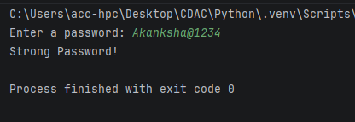
Q.9 Write a Python function clean_string(text) that takes a string and performs the following cleaning tasks using regex:
• Replace multiple spaces with a single space.
• Remove leading and trailing whitespace.
• Capitalize the first letter of each sentence.
def clean_string(text: str) -> str:
cleaned = " ".join(text.split())

sentences = cleaned.split(". ")
capitalized_sentences = []

for sentence in sentences:
if sentence:
capitalized_sentences.append(sentence[0].upper() + sentence[1:])

return ". ".join(capitalized_sentences)

sample_text = " hello world. how are you "
print(clean_string(sample_text))

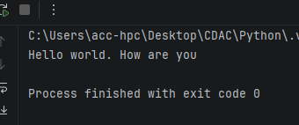
Q.10 Write a Python program that takes a string and replace all punctuation marks (e.g., ,, ., !, ?) with an empty string.
def remove_punctuation(text: str) -> str:
punctuation = "!\"#$%&'()*+,-./:;<=>?@[\\]^_`{|}~"
result = ""

for char in text:
if char not in punctuation:
result += char

return result

user_input = input("Enter a string: ")
print("Result:", remove_punctuation(user_input))

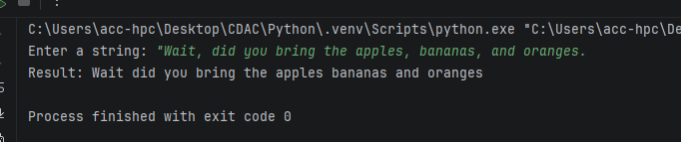
Q. 11 Read and Print a File:
• Create a text file named data.txt with a few lines of text.
• Write a Python script that opens data.txt in read mode, reads the entire content, and prints it to the console.
• Make sure to use a with statement to handle the file automatically.
• Count Lines in a File:
• Use the data.txt file from the previous question.
• Write a Python program that counts the number of lines in the file and prints the total count.
• Append to a File:
with open("data.txt", "w") as file:
file.write("Hello, world!\nWelcome to Python file handling.\nThis is line three.")

print("Reading File")
with open("data.txt", "r") as file:
content = file.read()
print(content)

with open("data.txt", "r") as file:
lines = file.readlines()
line_count = len(lines)

print("\nLine Count")
print("Total lines:", line_count)

with open("data.txt", "a") as file:
file.write("\nThis line was appended to the file.")

print("\nUpdated File Content")
with open("data.txt", "r") as file:
print(file.read())

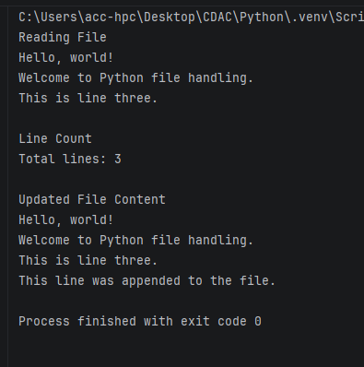
Q 12 Create a file named log.txt.
• Write a Python program that prompts the user to enter a log message.
• The program should then append this message, along with a timestamp, to the end of log.txt on a new line.
from datetime import datetime

message = input("Enter a log message: ")
timestamp = datetime.now().strftime("%Y-%m-%d %H:%M:%S")

with open("log.txt", "a") as file:
file.write(f"[{timestamp}] {message}\n")

print("Log entry saved to log.txt")
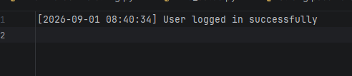
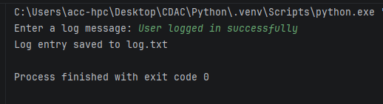
Q 13 Write a Simple CSV File:
• Write a Python script that takes a list of lists, where each inner list represents a row of data (e.g., [['Name', 'Age'], ['Alice', 30], ['John', 25]]).
• The script should write this data to a new CSV file named people.csv.
• Use the csv module for this task.
import csv

data = [
['Name', 'Age'],
['Kaveri', 21],
['Shubhangi', 22]
]

with open('people.csv', 'w', newline='') as file:
writer = csv.writer(file)
writer.writerows(data)

print("Data written to people.csv successfully.")

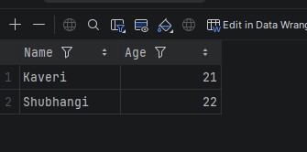
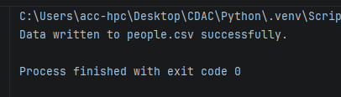

Assignment 8
Q1.
Write a Python program that accepts a sentence from the user and performs the following:
1. Count the number of vowels and consonants.
2. Count the number of digits and special characters.
3. Find the longest word in the sentence.
4. Display all words having more than 5 characters.
5. Check whether the sentence is a palindrome after removing spaces and converting it to lowercase.
sentence = input("Enter a sentence: ")

vowels_count = 0
consonants_count = 0
digits_count = 0
special_count = 0

vowels = "aeiouAEIOU"

for char in sentence:
if char.isalpha():
if char in vowels:
vowels_count += 1
else:
consonants_count += 1
elif char.isdigit():
digits_count += 1
elif not char.isspace():
special_count += 1

words = sentence.split()
cleaned_words = []
for word in words:
clean_w = "".join(ch for ch in word if ch.isalnum())
if clean_w:
cleaned_words.append(clean_w)

longest_word = max(cleaned_words, key=len) if cleaned_words else ""
words_longer_than_5 = [word for word in cleaned_words if len(word) > 5]

clean_sentence = "".join(char.lower() for char in sentence if char.isalnum())
is_palindrome = (clean_sentence == clean_sentence[::-1]) if clean_sentence else False

print("\n--- Analysis Results ---")
print("1. Vowels count:", vowels_count)
print(" Consonants count:", consonants_count)
print("2. Digits count:", digits_count)
print(" Special characters count:", special_count)
print("3. Longest word:", longest_word)
print("4. Words with more than 5 characters:", words_longer_than_5)
print("5. Is palindrome:", is_palindrome)

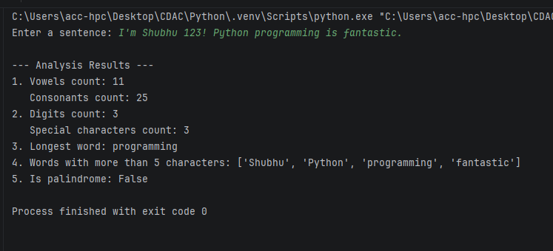
Q2.
Write a Python program to accept marks of n students into a list.
Perform the following operations:
1. Display all marks.
2. Find the highest and lowest marks without using max() or min().
3. Calculate the average marks.
4. Display students who scored above the average.
5. Count the number of students in each category:
o 75 and above – Distinction
o 60–74 – First Class
o 50–59 – Second Class
o Below 50 – Fail
6. Display the list in reverse order using a loop.
n = int(input("Enter number of students: "))
marks = []

for i in range(n):
score = float(input(f"Enter marks for student {i + 1}: "))
marks.append(score)

print("\nAll marks:", marks)

highest = marks[0]
lowest = marks[0]

for mark in marks:
if mark > highest:
highest = mark
if mark < lowest:
lowest = mark

print(f"Highest marks: {highest}")
print(f"Lowest marks: {lowest}")

total = 0
for mark in marks:
total += mark

average = total / n
print(f"Average marks: {average:.2f}")

above_average = []
for mark in marks:
if mark > average:
above_average.append(mark)

print("Marks above average:", above_average)

distinction = 0
first_class = 0
second_class = 0
fail = 0

for mark in marks:
if mark >= 75:
distinction += 1
elif mark >= 60:
first_class += 1
elif mark >= 50:
second_class += 1
else:
fail += 1

print("Distinction (75+):", distinction)
print("First Class (60-74):", first_class)
print("Second Class (50-59):", second_class)
print("Fail (Below 50):", fail)

reverse_marks = []
for i in range(len(marks) - 1, -1, -1):
reverse_marks.append(marks[i])

print("Marks in reverse order:", reverse_marks)

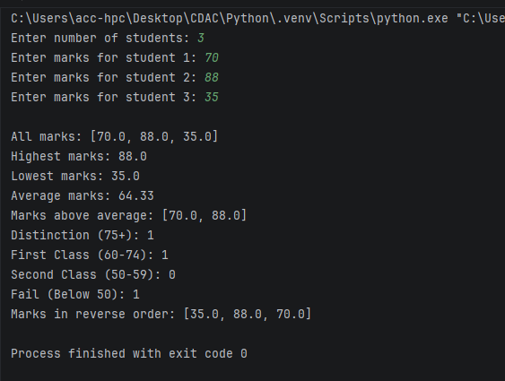

Q3.
Create a tuple containing employee records in the form:
(employee_id, employee_name, salary)
Write a program to:
1. Display all employees.
2. Find the employee receiving the highest salary.
3. Calculate the average salary.
4. Display employees whose salary is greater than the average.
5. Count employees based on salary categories:
o Below 30,000
o 30,000–60,000
o Above 60,000
6. Search for an employee by employee ID.
employees = (
(101, "pooja", 45000),
(102, "sai", 72000),
(103, "kaveri", 28000),
(104, "sneha", 60000),
(105, "sakshi", 31000)
)

print("1. All Employees:")
for emp in employees:
print(f"ID: {emp[0]}, Name: {emp[1]}, Salary: {emp[2]}")

highest_emp = employees[0]
for emp in employees:
if emp[2] > highest_emp[2]:
highest_emp = emp

print(f"\n2. Highest Salary Employee: {highest_emp[1]} (ID: {highest_emp[0]}) with Salary: {highest_emp[2]}")

total_salary = 0
for emp in employees:
total_salary += emp[2]

average_salary = total_salary / len(employees)
print(f"\n3. Average Salary: {average_salary:.2f}")

print("\n4. Employees with Salary Above Average:")
for emp in employees:
if emp[2] > average_salary:
print(f"ID: {emp[0]}, Name: {emp[1]}, Salary: {emp[2]}")

below_30k = 0
between_30k_60k = 0
above_60k = 0

for emp in employees:
if emp[2] < 30000:
below_30k += 1
elif 30000 <= emp[2] <= 60000:
between_30k_60k += 1
else:
above_60k += 1

print("\n5. Salary Categories Count:")
print("Below 30,000:", below_30k)
print("30,000 - 60,000:", between_30k_60k)
print("Above 60,000:", above_60k)

search_id = int(input("\nEnter Employee ID to search: "))
found = False

for emp in employees:
if emp[0] == search_id:
print(f"Employee Found -> ID: {emp[0]}, Name: {emp[1]}, Salary: {emp[2]}")
found = True
break

if not found:
print("Employee ID not found.")

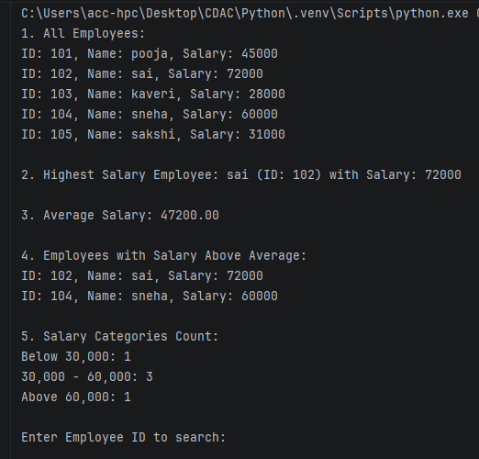

Q4.
Accept two lists of integers from the user and convert them into sets.
Write a program to:
1. Display unique elements from both lists.
2. Find the union.
3. Find the intersection.
4. Find elements present only in the first list.
5. Find elements present only in the second list.
6. Display common even numbers.
7. Display common odd numbers.
list1 = list(map(int, input("Enter integers for List 1: ").split()))
list2 = list(map(int, input("Enter integers for List 2: ").split()))

set1 = set(list1)
set2 = set(list2)

print("\n1. Unique elements in List 1:", set1)
print(" Unique elements in List 2:", set2)

union_set = set1 | set2
print("2. Union:", union_set)

intersection_set = set1 & set2
print("3. Intersection:", intersection_set)

only_in_first = set1 - set2
print("4. Elements present only in first list:", only_in_first)

only_in_second = set2 - set1
print("5. Elements present only in second list:", only_in_second)

common_even = {num for num in intersection_set if num % 2 == 0}
print("6. Common even numbers:", common_even)

common_odd = {num for num in intersection_set if num % 2 != 0}
print("7. Common odd numbers:", common_odd)

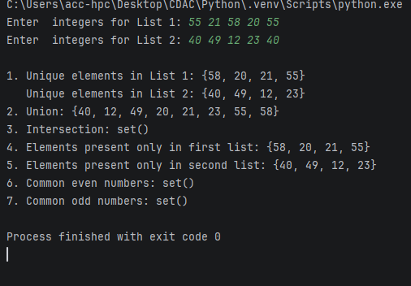

Q5.
Create a dictionary containing student names and their marks in three subjects.
Example:
students = {
"Amit": [75, 82, 68],
"Neha": [91, 88, 95],
"Rahul": [45, 52, 48]
}
Write a program to:
1. Calculate total and average marks for each student.
2. Assign grades using conditional statements.
3. Display students who have passed in all subjects.
4. Display the student with the highest average.
5. Count the number of students in each grade.
6. Search for a student by name.
students = {
"Amit": [75, 82, 68],
"Neha": [91, 88, 95],
"Rahul": [45, 52, 48]
}

grade_counts = {"A": 0, "B": 0, "C": 0, "F": 0}
highest_avg = -1
top_student = ""

for name, marks in students.items():
total = sum(marks)
avg = total / len(marks)

if avg >= 85:
grade = "A"
elif avg >= 70:
grade = "B"
elif avg >= 50:
grade = "C"
else:
grade = "F"

grade_counts[grade] += 1

if avg > highest_avg:
highest_avg = avg
top_student = name

print(f"Student: {name} | Total: {total} | Average: {avg:.2f} | Grade: {grade}")

print("\nPassed in all subjects (min 40 in each):")
for name, marks in students.items():
if all(m >= 40 for m in marks):
print(name)

print(f"\nHighest Average: {top_student} with {highest_avg:.2f}")

print("\nGrade Counts:")
for g, c in grade_counts.items():
print(f"Grade {g}: {c}")

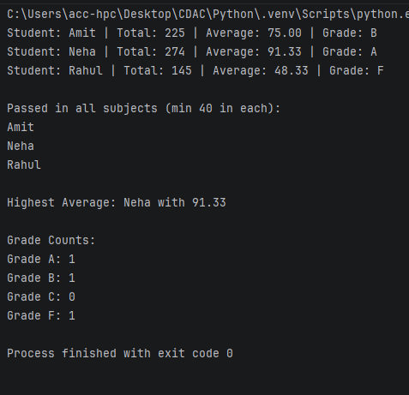

Q6.
Create a menu-driven Python program using user-defined functions.
The menu should contain:
1. Check Prime Number
2. Check Palindrome
3. Find Factorial
4. Generate Fibonacci Series
5. Exit
Create a separate function for each operation.
def is_prime(n):
if n <= 1:
return False
for i in range(2, int(n ** 0.5) + 1):
if n % i == 0:
return False
return True

def is_palindrome(val):
s = str(val).lower()
return s == s[::-1]

def factorial(n):
if n < 0:
return "Not defined for negative numbers"
result = 1
for i in range(1, n + 1):
result *= i
return result

def fibonacci(n):
if n <= 0:
return []
elif n == 1:
return [0]
series = [0, 1]
for i in range(2, n):
series.append(series[-1] + series[-2])
return series

while True:
print("\n MENU ")
print("1. Check Prime Number")
print("2. Check Palindrome")
print("3. Find Factorial")
print("4. Generate Fibonacci Series")
print("5. Exit")

choice = input("Enter your choice (1-5): ")

if choice == '1':
num = int(input("Enter a number: "))
if is_prime(num):
print(f"{num} is a Prime number.")
else:
print(f"{num} is not a Prime number.")

elif choice == '2':
val = input("Enter a number or string: ")
if is_palindrome(val):
print(f"'{val}' is a Palindrome.")
else:
print(f"'{val}' is not a Palindrome.")

elif choice == '3':
num = int(input("Enter a number: "))
print(f"Factorial of {num} is {factorial(num)}")

elif choice == '4':
terms = int(input("Enter number of terms: "))
print(f"Fibonacci series: {fibonacci(terms)}")

elif choice == '5':
print("Exiting program.")
break

else:
print("Invalid choice! Please select 1-5.")

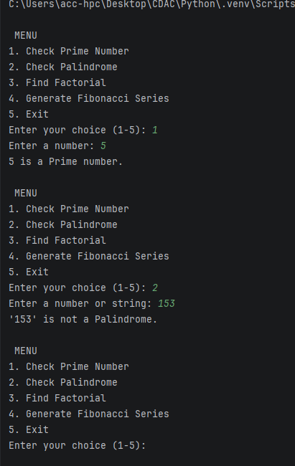

Q7.
Create a class BankAccount with the following attributes:
account_number
customer_name
balance
Create methods:
deposit()
withdraw()
check_balance()
display_details()
Apply the following conditions:
• Deposit amount must be greater than zero.
• Withdrawal amount must not exceed the balance.
• Display an appropriate message for insufficient balance.
• Allow multiple transactions using a loop.
• Provide a menu:
1. Deposit
2. Withdraw
3. Check Balance
4. Account Details
5. Exit
class BankAccount:
def __init__(self, account_number, customer_name, balance=0.0):
self.account_number = account_number
self.customer_name = customer_name
self.balance = balance

def deposit(self, amount):
if amount > 0:
self.balance += amount
print(f"Successfully deposited {amount:.2f}")
else:
print("Deposit amount must be greater than zero.")

def withdraw(self, amount):
if amount <= 0:
print("Withdrawal amount must be greater than zero.")
elif amount > self.balance:
print("Insufficient balance! Transaction failed.")
else:
self.balance -= amount
print(f"Successfully withdrew {amount:.2f}")

def check_balance(self):
print(f"Current Balance: {self.balance:.2f}")

def display_details(self):
print(f"Account Number: {self.account_number}")
print(f"Customer Name: {self.customer_name}")
print(f"Balance: {self.balance:.2f}")

acc_num = input("Enter Account Number: ")
cust_name = input("Enter Customer Name: ")
initial_balance = float(input("Enter Initial Balance: "))

account = BankAccount(acc_num, cust_name, initial_balance)

while True:
print("\n MENU ")
print("1. Deposit")
print("2. Withdraw")
print("3. Check Balance")
print("4. Account Details")
print("5. Exit")

choice = input("Enter your choice (1-5): ")

if choice == '1':
amt = float(input("Enter deposit amount: "))
account.deposit(amt)
elif choice == '2':
amt = float(input("Enter withdrawal amount: "))
account.withdraw(amt)
elif choice == '3':
account.check_balance()
elif choice == '4':
account.display_details()
elif choice == '5':
print("Thank you for banking with us!")
break
else:
print("Invalid choice! Please select 1-5.")

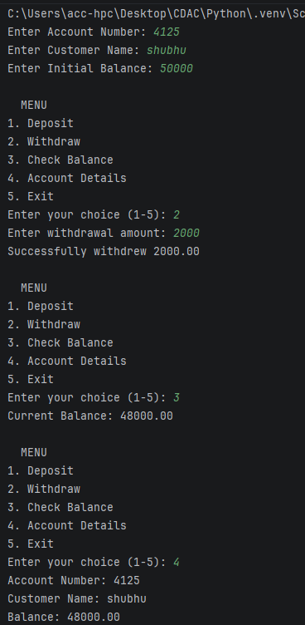

Q8.
Write a Python program using the re module to validate user input.
Validate:
1. Mobile number
2. Email address
3. Password
4. PIN code
5. Username
import re

def validate_mobile(mobile):
pattern = r'^[6-9]\d{9}$'
return bool(re.match(pattern, mobile))

def validate_email(email):
pattern = r'^[a-zA-Z0-9._%+-]+@[a-zA-Z0-9.-]+\.[a-zA-Z]{2,}$'
return bool(re.match(pattern, email))

def validate_password(password):
pattern = r'^(?=.*[a-z])(?=.*[A-Z])(?=.*\d)(?=.*[@$!%*?&])[A-Za-z\d@$!%*?&]{8,}$'
return bool(re.match(pattern, password))

def validate_pincode(pincode):
pattern = r'^[1-9]\d{5}$'
return bool(re.match(pattern, pincode))

def validate_username(username):
pattern = r'^[a-zA-Z0-9_]{3,16}$'
return bool(re.match(pattern, username))

mobile = input("Enter Mobile Number: ")
email = input("Enter Email Address: ")
password = input("Enter Password: ")
pincode = input("Enter PIN Code: ")
username = input("Enter Username: ")

print("\n--- Validation Results ---")
print("Mobile Number Valid:", validate_mobile(mobile))
print("Email Address Valid:", validate_email(email))
print("Password Valid:", validate_password(password))
print("PIN Code Valid:", validate_pincode(pincode))
print("Username Valid:", validate_username(username))

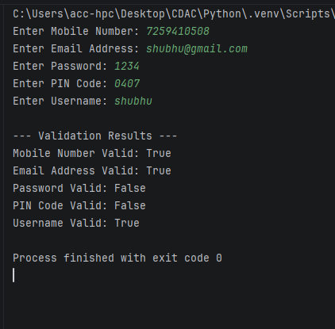
Q9. Use regular expressions and conditional statements to display whether each input is Valid or Invalid.
For the password, enforce:
• At least 8 characters
• At least one uppercase letter
• At least one lowercase letter
• At least one digit
• At least one special character
import re

def validate_password(password):
pattern = r"^(?=.*[a-z])(?=.*[A-Z])(?=.*\d)(?=.*[@$!%*?&])[A-Za-z\d@$!%*?&]{8,}$"

if re.match(pattern, password):
return "Valid"
else:
return "Invalid"

passwords = ["Secr3t!2", "pooja!", "rani123@", "BHgtcmE1!", "NoDigit!", "NoSpecial1"]

for p in passwords:
print(f"Input: {p} -> {validate_password(p)}")

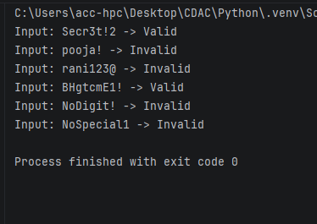

Assignment 9

Q1 Write a function apply_discount(price, discount_percentage) where:
• An assert statement checks that discount_percentage is strictly between 0 and 100.
• Another assert statement checks that the final price is never negative or higher than the original price.
• Test your function with a valid discount (e.g., 20%) and an invalid discount (e.g., 120%) to show the traceback.
def apply_discount(price, discount_percentage):
assert 0 < discount_percentage < 100, "Discount percentage must be strictly between 0 and 100."
final_price = price * (1 - discount_percentage / 100)
assert 0 <= final_price <= price, "Final price must be between 0 and the original price."
return final_price

try:
print(apply_discount(100, 20))
except AssertionError as e:
print(e)

try:
print(apply_discount(100, 120))
except AssertionError as e:
print(e)

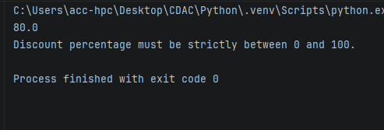

Q2. Create a program that prompts the user to enter two numbers (A and B) and outputs the result of A / B. Wrap the execution inside a try block and implement specific except clauses to handle.
• ValueError: Handled when a user inputs a non-numeric string (e.g., "abc").
• ZeroDivisionError: Handled when B is zero.
try:
a = float(input("Enter first number (A): "))
b = float(input("Enter second number (B): "))
result = a / b
print("Result of A / B:", result)
except ValueError:
print("Error: Invalid input! Please enter valid numeric values.")
except ZeroDivisionError:
print("Error: Division by zero is not allowed.")

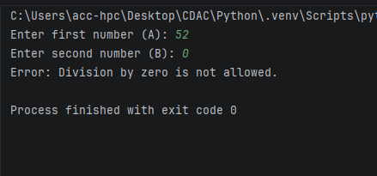

Q3 Write a program that requests a filename from the user and attempts to open it in read-only mode.
• Intercept FileNotFoundError if the file doesn't exist.
• Intercept PermissionError if the user lacks the credentials to open the file
filename = input("Enter the filename: ")

try:
with open(filename, "r") as file:
content = file.read()
print("\nFile contents:\n")
print(content)
except FileNotFoundError:
print(f"Error: The file '{filename}' does not exist.")
except PermissionError:
print(f"Error: You lack the permissions to read '{filename}'.")

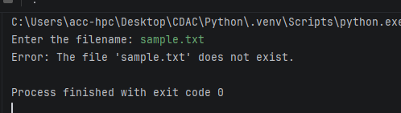
Q4 Create a class named Countdown.
• The constructor _init_(self, start) should accept a starting integer.
• Implement _iter_(self) to return the iterator object itself.
• Implement _next_(self) to return numbers counting down to 0.
• Once it hits 0, it should raise a StopIteration exception to halt the loop.
class Countdown:
def __init__(self, start):
self.current = start

def __iter__(self):
return self

def __next__(self):
if self.current < 0:
raise StopIteration
value = self.current
self.current -= 1
return value

print("Counting down from 5:")
for num in Countdown(5):
print(num)

print("\nCounting down from 3 manually:")
cd = Countdown(3)
print(next(cd))
print(next(cd))
print(next(cd))
print(next(cd))

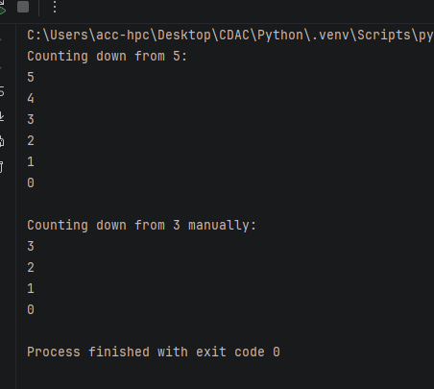

Q5 Write a generator function named fibonacci_gen(limit).
• It should calculate and yield Fibonacci numbers one by one.
• The generator must stop yielding once a number exceeds the specified limit.
def fibonacci_gen(limit):
a, b = 0, 1
while a <= limit:
yield a
a, b = b, a + b

print("Fibonacci numbers up to limit 50:")
for num in fibonacci_gen(50):
print(num, end=" ")

